**PRACTICAL NO : 04**

**Title : Design and develop custom Application (Mini Project) using Salesforce Cloud.**

**STEPS TO CREATE AN APPLICATION(mini project) :**

1. Open salesforce in Lightning Experience

2. Open App Launcher→ View all → Quick Search → App Manager → Click on New Lightning App → fill the mention information →Next →App option(optional ) →Next → Add Utility (optoinal)--> Next →Navigation Item(you can add item)--> Next → User Profile(use the user profile that can access this app) → Save and Finish.

You will get Lightning Experience App Manager Window → Search Your App by its name in App Launcher → just by entering some character, you can see app name with its logo → Click on App → you can see your application appearance in window → Output

**Note : steps images are provided here……..**

1. . Open salesforce in Lightning Experience

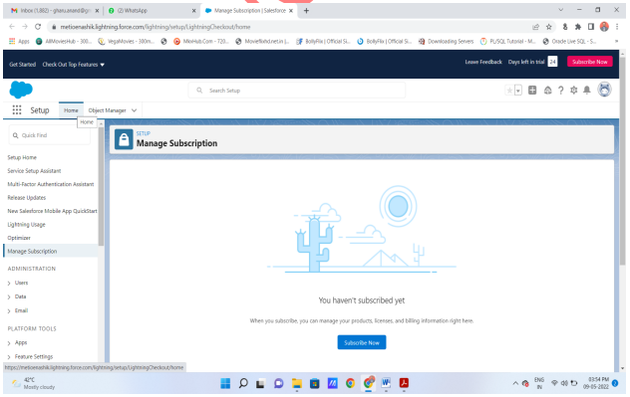

2. Open App Launcher View all ( Quick Search App Manager) Click on New Lightning App

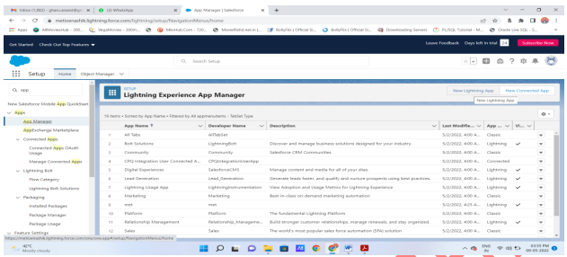

3. fill the mention information in new lightning app : then next

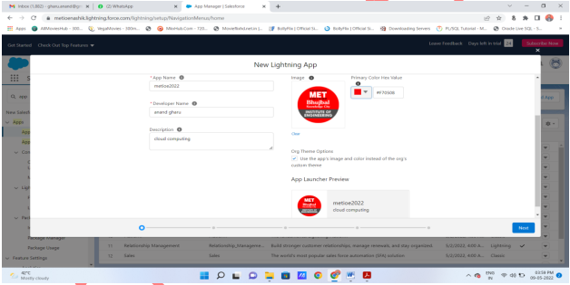

4. App option(optional ) Next

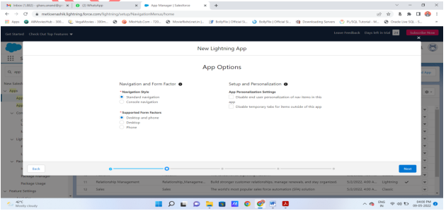

5. Add Utility (optoinal) Next .

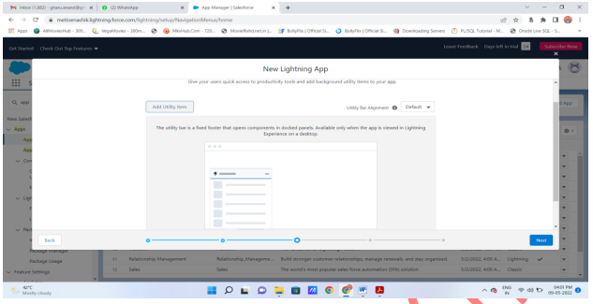

6. Navigation Item(you can add item) Next

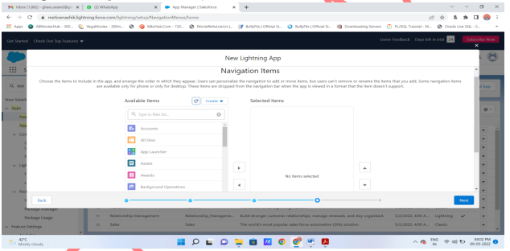

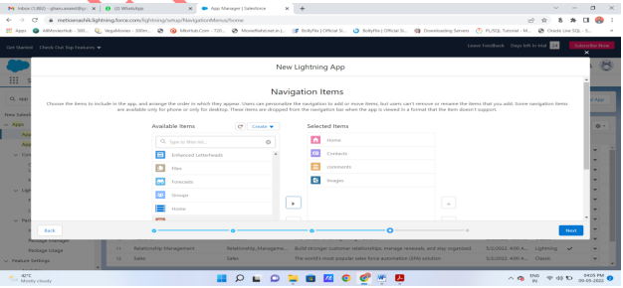

7. User Profile(use the user profile that can access this app) Save and Finish

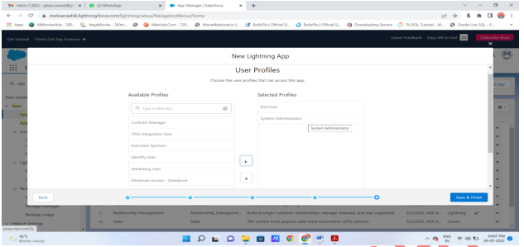

8. You will get Lightning Experience App Manager Window(here, you can see your application)

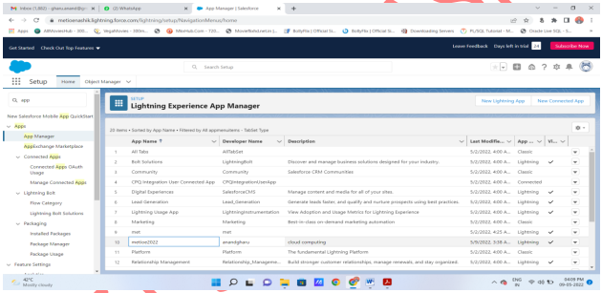

9. Search Your App by its name in App Launcher just by entering some character, you can see app name with its logo Click on App you can see your application appearance in window Output.

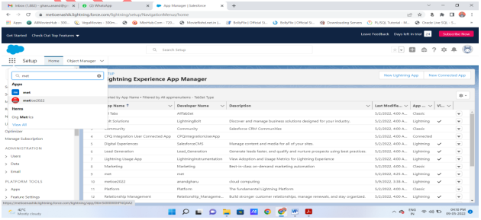

**Output : You can see your application here….**

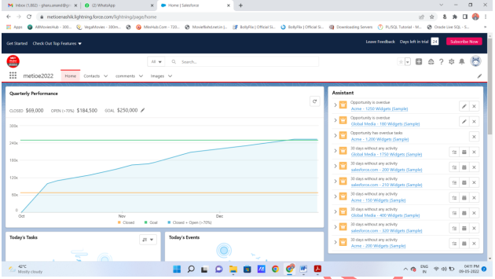

10. You can add new contact in your application :

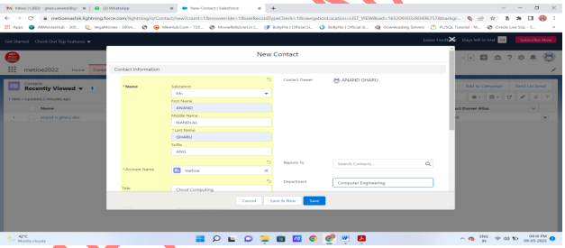

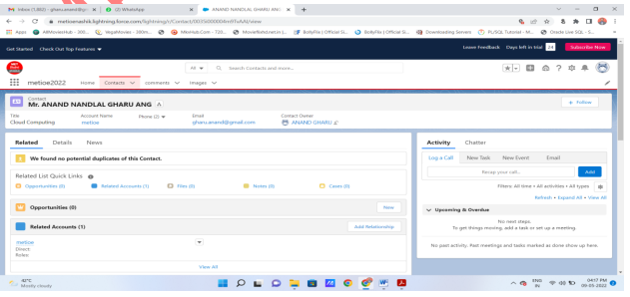

11. You can add images also :

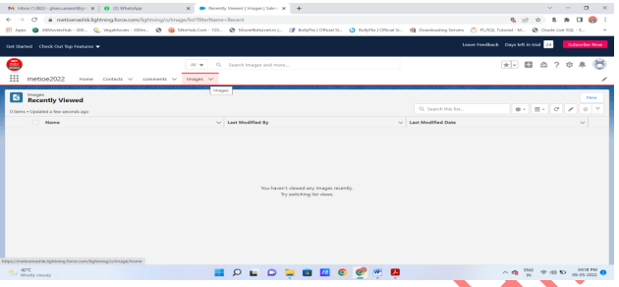

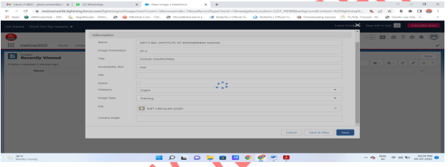

You can see here that image is added as MET Circular logo(its image file name) :

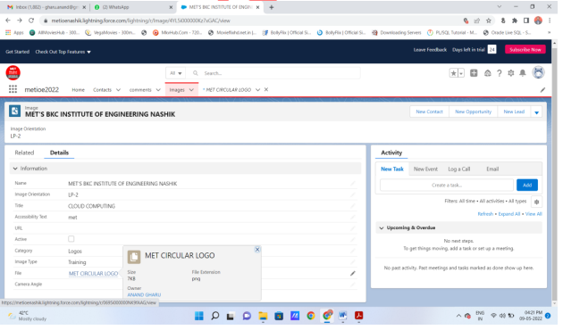

You can see actual image by clicking on link :

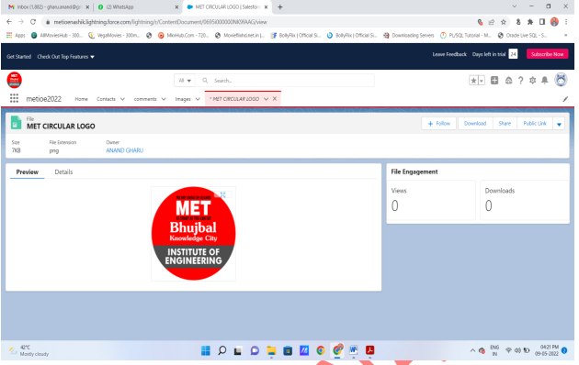

**You mini project application get created**

**Note : you can add navigations, utilities , profiles as per your requirements for your mini project application**